

**Tribhuvan University**

**Institute Of Science and Technology**

**A PROJECT PROPOSAL**

**ON**

**“TREKKING EQUIPMENT RENTAL”**

Submitted to

**Central Department of Computer Science and Information Technology**

**Birendra Multiple Campus**

***In partial fulfillment of the requirements for the Bachelors of Science in Computer Science and Information Technology***

Submitted by

**Suyog Mani Kandel (68) (Registration no.: 5-2-19-167-2019) (24913/076)**

**Prakriti Adhikari (20) (Registration no.: 5-2-19-114-2019) (24878/076)**

**Sudip Timilsina (32) (Registration no.: 5-2-19-163-2019) (24909/076)**

NOVEMBER, 2023

Table of Contents

1. Introduction 1

2. Problem Statement 1

3. Objectives 1

4. Methodology 2

4.1. Requirement Identification 2

4.1.1. Study of Existing System 2

4.1.2. Literature Review 2

4.1.3. Requirement Analysis 2

4.2. Feasibility Study 3

4.2.1 Technical Feasibility 3

4.2.2 Operational Feasibility 3

4.2.3 Economic Feasibility 3

4.2.4 Schedule Feasibility (Gantt chart showing the project timeline) 4

4.3. High Level Design of System 5

5. Expected Outcome 7

6. References 7

**Trekking Equipment Rental**

# Introduction

Trekking has been gaining popularity in recent years. Many people are drawn to trekking as a way to explore nature, challenge themselves physically and mentally, and disconnect from the stresses of modern life. Trekking allows individuals to immerse themselves in the natural beauty of various landscapes, from mountain trails to dense forests, coastal paths, and more. Trekking gears can vary in price depending on their quality, brand, and the specific needs of the trekking activity.

Trekking Equipment Rental is the website where costumer can rent any Trekking equipment’s simply by clicking. This website provides reliable and affordable equipment’s. Bringing affordable and trusted equipment that consumer can rent instantly. This site also provides several dynamic features.

# Problem Statement

* Buying trekking gear cannot be practical and cost effective, especially for those who don't trek frequently or if you're planning a one-time trek to a specific destination.
* Ill-fitting equipment such as hiking boots and backpacks can lead to discomfort and injury during your trek.
* Trekking equipment can vary depending on the specific needs of the trekking activity.
* Change of preference or taste.

# Objectives

* Renting allows you to access high-quality gear without the upfront costs of purchasing expensive equipment.
* Ensure that the gears rented are of desired size and fits properly.
* To make easy adaptation according to the requirement.
* To make easy alteration according to the change of preference.

# Methodology



## Requirement Identification



### Study of Existing System

As Trekking is a popular adventure activity in Nepal, attracting a significant number of tourists and local trekkers each year. As travelers from around the world and local enthusiasts explore the breathtaking landscapes and trails of the Himalayas, they require specialized trekking gear to ensure a safe and enjoyable experience. However, carrying bulky trekking equipment during international or domestic travel can be cumbersome. Additionally, finding reliable rental options upon arrival at the trekking destinations can be challenging, leading to potential inconveniences and subpar gear quality. To address these issues and enhance the trekking experience for both tourists and local trekkers, the “Trekking Equipment Rental“is proposed.

### Literature Review

The trekking gear rental market is a promising avenue for growth and expansion, particularly due to the increasing popularity of adventure tourism and the current trend of online shopping. By offering rental options, businesses can cater to the evolving preferences and demands of customers who may prefer the flexibility of renting over buying trekking equipment.

By focusing on the growing demand for adventure tourism and the benefits of rental options, trekking gear rental businesses can tap into this market's potential for growth and offer an attractive alternative to buying gear outright.

### Requirement Analysis

Functional requirements explain how the system must work, while non-functional requirements explain how the system should perform.

Performance, security, reliability, maintainability and availability are the non-functional requirements of our project.

## Feasibility Study

### 4.2.1 Technical Feasibility

For both end users and developers our project requires a simple hardware i.e. a computer or a laptop with normal processing speed and GUI based technology as well as good internet connection and software includes a visual studio code, Apache server, MySQL database which can be downloaded from many official respective sites. This project will be completed in the most recent and widely used web development tool i.e. React js as Front end and Laravel which is a powerful PHP framework built for developers who need a simple and elegant toolkit to create full-featured web application. All the requirements can be easily available so we must say it is technically feasible.

**Web development tool:** React js and Laravel.

**Tools used**: Visual Studio Code, XAMPP, Apache server, MySQL database

**Hardware Requirement:** A working computer system.

### 4.2.2 Operational Feasibility

For the system to work functionally, basic computer knowledge, web site knowledge and power supply is necessary which is abundant in every organization and also as we mentioned earlier only few technologies will be used to operate the website and simple training demonstration of working website will be required for admin so it is operationally feasible.

### 4.2.3 Economic Feasibility

As our project needs computers and some open source software which can be easily available through internet surfing and are free of cost, the implementing cost will be very low compared to other websites with different hardware requirement systems and which uses premium software for development. Admin can operate our system with less effort and only few technologies are required so the cost of manpower is not a necessity that’s why it is economically feasible.

### Schedule Feasibility (Gantt chart showing the project timeline)

**Development Methodology**

We have chosen Agile Development Methodology for our project because development is divided into small iterations called Sprints. This is a better development methodology due to its continuous planning, testing, integration, risk evaluation and control on the progress of the project and thereupon reduces the chances of project failure.

Agile is used to plan quickly, develop quickly, release quickly and revise quickly.

In Agile, a project is converted into small parts known as Sprints. Each sprint can be completed using waterfall steps like; Conception, Initiation, Analysis, Design, Construction, Testing, Implementation and finally Maintenance.

**Table 4.2.4.1: Gantt Chart**

|  |  |  |  |  |  |  |  |  |  |  |  |  |
| --- | --- | --- | --- | --- | --- | --- | --- | --- | --- | --- | --- | --- |
| Weeks  Phase | 1 | 2 | 3 | 4 | 5 | 6 | 7 | 8 | 9 | 10 | 11 | 12 |
| Study and analysis | 1W |  |  |  |  |  |  |  |  |  |  |  |
| Feasibility study |  | 2W |  |  |  |  |  |  |  |  |  |  |
| Data fetching & Coding |  |  |  |  | 4W |  |  |  |  |  |  |  |
| Implementation & Testing |  |  |  |  |  | 3W |  |  |  |  |  |  |
| Documentation |  |  |  |  | 9W |  |  |  |  |  |  |  |
| Review |  |  | 1W |  |  |  |  |  |  |  | 1W |  |
| Presentation |  |  | 1W |  |  |  |  |  |  |  |  | 1W |

## High Level Design of System

**Architectural Design**

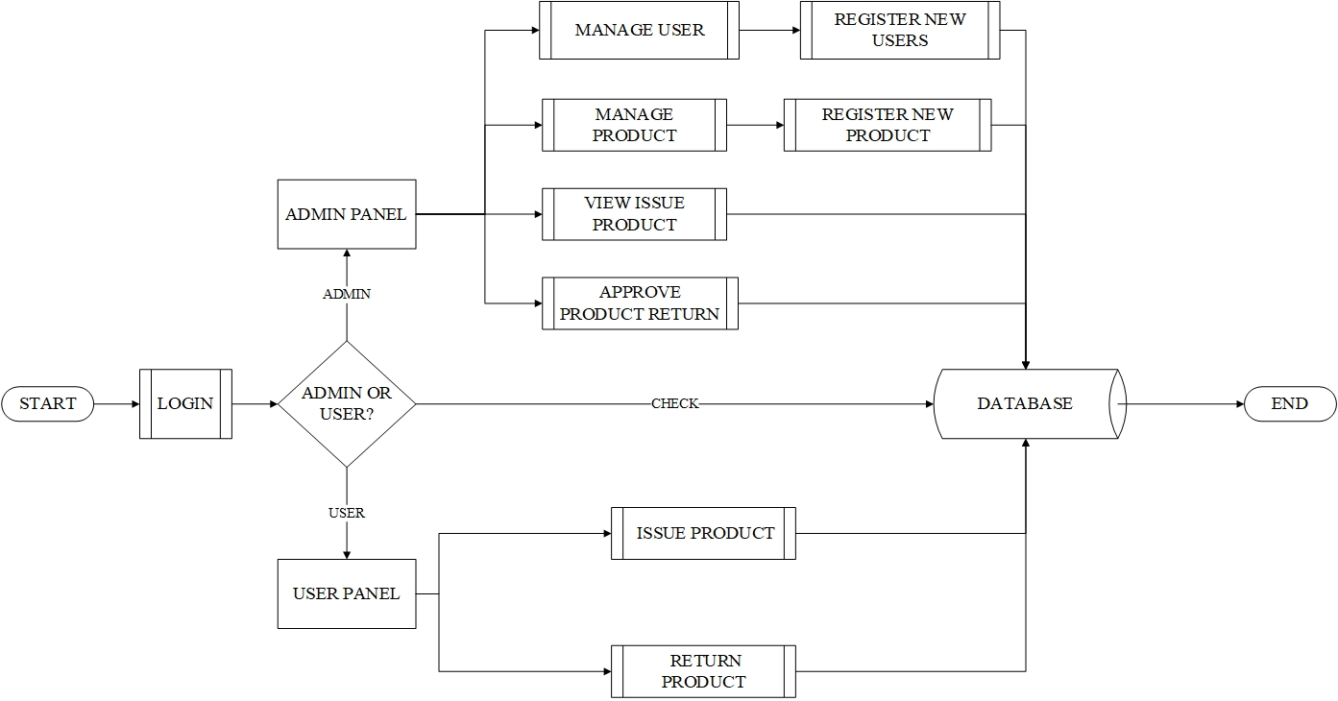

**Fig 4.3.1: Architectural Design of Trekking Equipment Rental**

**Use Case Diagram**

A use case diagram is usually simple. It does not show the detail of the use cases:

• It only summarizes some of the relationships between use cases, actors, and systems.

• It does not show the order in which steps are performed to achieve the goals of each use case.

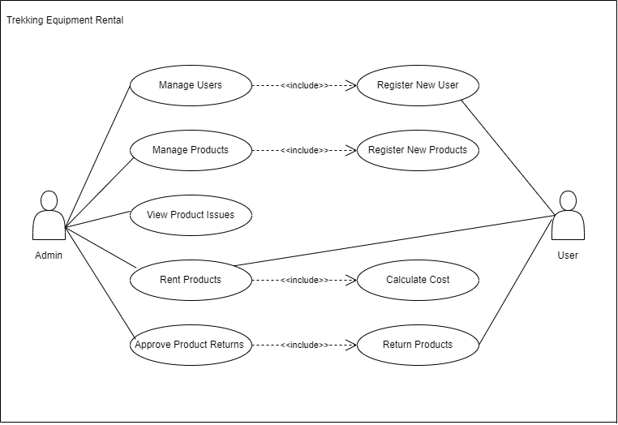

**Fig 4.3.2: Use Case Diagram of Trekking Gears Rental**

# Expected Outcome

We can expect a fully functional website that can meet all the necessary needs and requirements of the consumer. Such as providing quality services as well as budget friendly products according to the needs and desire of the consumer with fast and easy service. Ensuring the trekking experience would be convenient and budget-friendly as possible.

# References

* “Buying and Renting Trekking Gears in Kathmandu,”https://nepaltrekroutes.com/buying-and-renting-trekking-gears-in-kathmandu/. [Accessed: 25-Apr-2023].
* “Trekking Gears Rental,” www.lowergear.com, https://www.lowergear.com/all-camping-and-travel-gear. [Accessed: 25-Apr-2023].